Matthew Koken

COEN 171

Homework 1

1. Is App Inventor an interpreted or compiled Programming Language?

App Inventor is an interpreted language. The base level of App Inventor is Java – an interpreted language that is used for Android app development. Like Java, the App Inventor is built into a .apk – the executable - that can be run on the Android jvm, allowing for some level of platform independence. Here, the program is processed by software to run.

1. Is App Inventor a compiled or scripting PL?

App Inventor is a compiled programming language. In order to be a scripting language, there should be no intermediate compilation or interpretation step. However, App Inventor needs to be built into an .apk or .aia before it can be run – this aspect makes App Inventor a compiled language. The computer cannot understand the graphical representation that we build – it must be compiled or interpreted into machine usable executable.

1. Can you declare global variables in App Inventor?

Yes, you can declare global variables in App Inventor. Within the variables drawer, there is an option to “initialize global name to.” This block allows creation of a variable that can be accessed from any screen – a global variable.

1. How are function parameters passed?

Function parameters are passed in the procedures blocks.

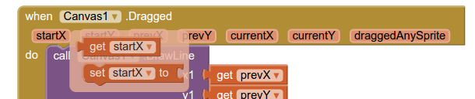 Here, the variables such as startX are passed into the function in the header of the block. Each orange parameter slot added to the block receives the specified variable value. In addition, the dropdown menu (where Canvas1 is) is also a parameter. Here, the variable to be passed in is selected through the dropdown menu instead of dragging the variable to the slot like the other parameters.

1. Can you pass an array as a function parameter?

Yes, arrays can be passed as a function parameter.

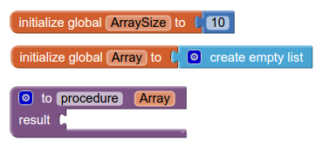

1. What are the main strengths and limitations of App Inventor as a Programming Language?

Strengths

* Ease of use – graphical interface makes interface building easy. Logic is simple and does not require extensive learning of syntax.
* Ease of running. Given an android device with the App Inventor App, a compatible emulator, or the USB companion app, it is fairly simple to run your app.
* Great for beginning to learn programming and logic, designing apps for Android.

Limitations

* Compatibility – App Inventor is built for a much older version of the Android operating system. Newer versions don't necessarily work as well or offer full compatibility. The interface is also a little outdated and clunky to use
* Usability. You are limited to the prebuilt blocks and logic functions supplied. Here, lack of features may limit the possibilities for what can be built. The interface builder also limits the interface that can be built.

Blocks:

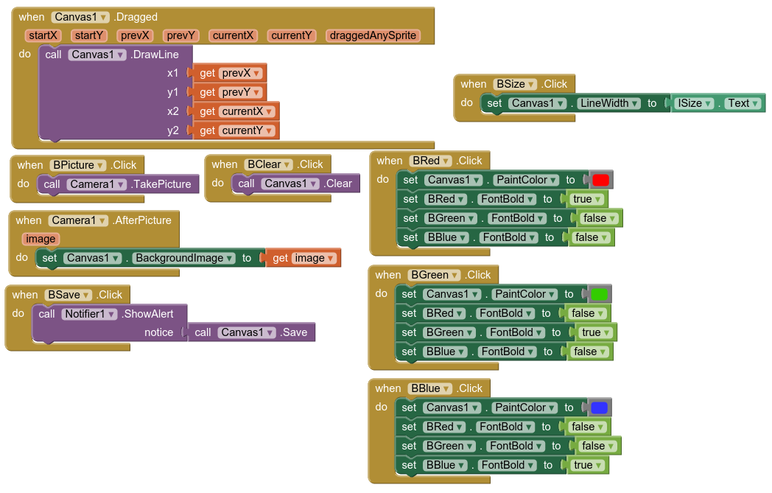

App in use:

